**Uber business problem**

1. **Status distribution**

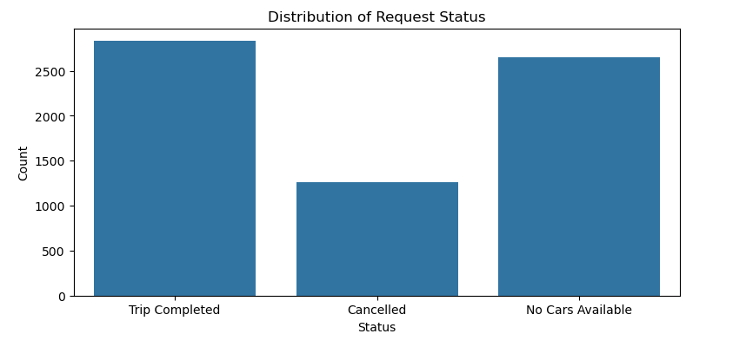

**Conclusion:** The issue of car unavailability and cancellations represents a significant portion of failed requests, contributing to potential revenue loss. Addressing these could improve Uber's operational efficiency.

1. **Pickup Point vs. Status**

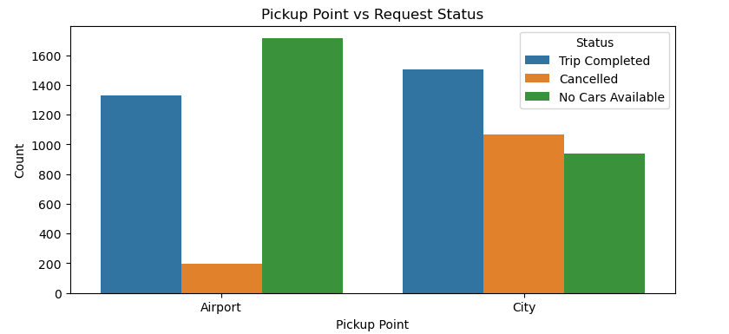

**Conclusion :** The airport faces a major issue of car availability, while the city struggles more with cancellations. Addressing the shortage of cars at the airport and reducing cancellations in the city would improve Uber's service and reduce revenue loss.

1. Request Hour vs. Status

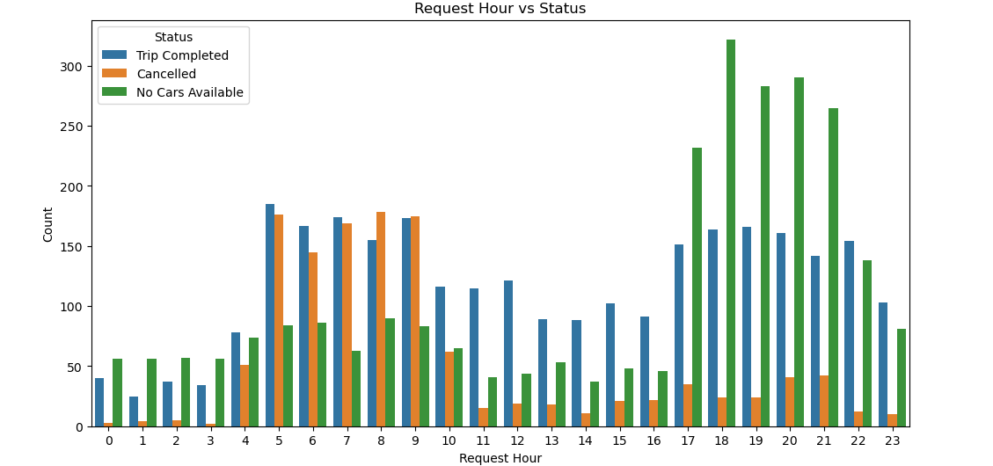

**Conclusion:** The chart indicates that early morning trips are frequently canceled, while evening peak hours (5 PM - 9 PM) experience high demand and limited car availability.

1. Status Distribution by Time of Day (Morning, Afternoon, Evening, Night)

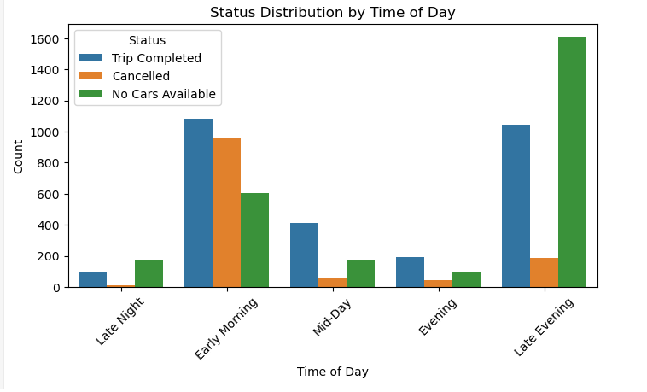

**Conclusion:** The chart shows that most trips are completed during the late evening and early morning hours. Cancellations are highest during the late night and mid-day periods, while "No Cars Available" issues are more frequent in the early morning and late evening.

1. Top 10 Drivers with Most Cancellations

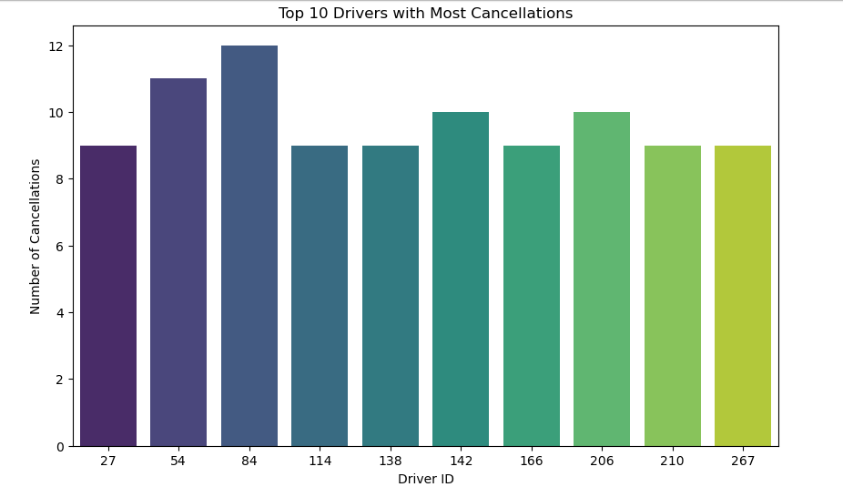

**Conclusion:** The chart shows the top 10 drivers with the most cancellations. Driver ID 84 has the highest number of cancellations, followed by Driver ID 54 and Driver ID 114.

**Overall Conclusion:**

**The ride-sharing service is experiencing high demand and capacity issues, particularly during evening peak hours. Cancellations are frequent, especially in the late night and mid-day periods. Some drivers have a higher tendency to cancel trips, which could be due to various factors such as personal reasons, vehicle issues, or traffic congestion.**

**To improve the service, the company may need to increase the number of available drivers during peak hours, implement measures to reduce cancellations, and investigate the reasons behind driver cancellations.**